Local Flask Endpoint for ML Model

Minimal Local Endpoint Example

Step 1 - Install Flask
pip install flask joblib pandas scikit-learn
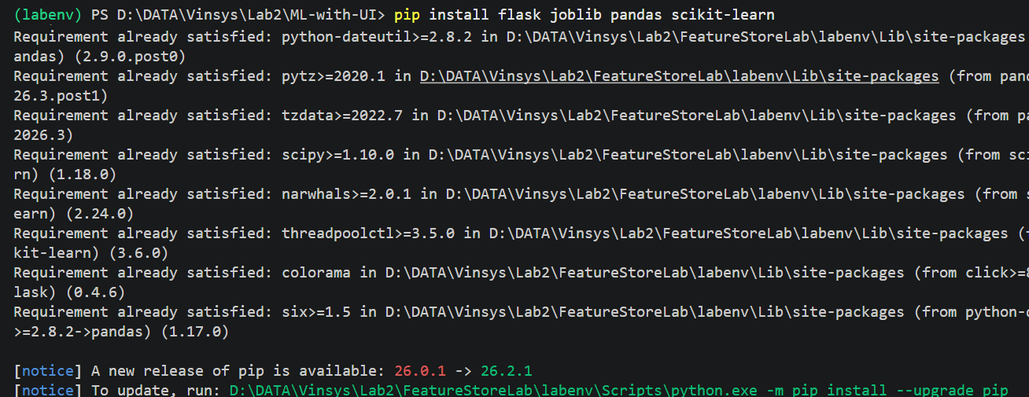

Step 2 - Train and Save Model (quick demo)
# train_local_model.py
import pandas as pd
from sklearn.tree import DecisionTreeClassifier
import joblib
# Tiny dataset
df = pd.DataFrame({
"MonthlyDataUsage":[10,6,15,8],
"AverageCallCount":[120,90,160,110],
"MonthlyBill":[800,450,1200,650],
"UsageBillingRatio":[0.012,0.013,0.012,0.012],
"BillingStatus":[0,0,1,0]
})
X = df[["MonthlyDataUsage","AverageCallCount","MonthlyBill","UsageBillingRatio"]]
y = df["BillingStatus"]
model = DecisionTreeClassifier(random_state=42)
model.fit(X, y)
joblib.dump(model, "local_model.pkl")
print("Model saved as local_model.pkl")
Run once:
py train_local_model.py

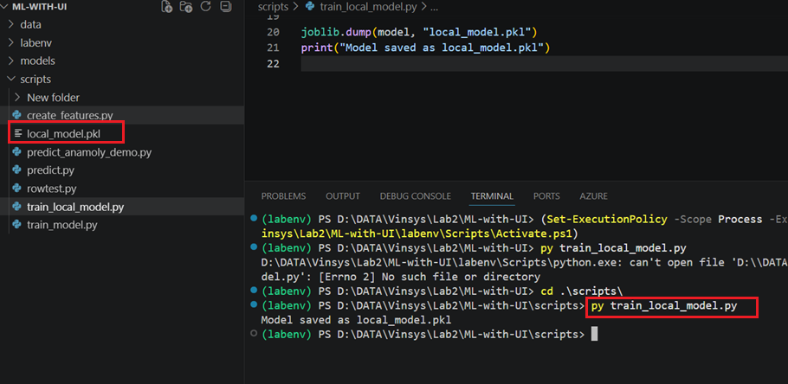

Step 3 - Create Local Endpoint
# app.py
from flask import Flask, request, jsonify
import joblib
import pandas as pd
app = Flask(__name__)
model = joblib.load("local_model.pkl")
@app.route("/predict", methods=["POST"])
def predict():
data = request.get_json()
df = pd.DataFrame(data)
prediction = model.predict(df)
return jsonify({"prediction": prediction.tolist()})
if __name__ == "__main__":
app.run(port=5000)
Run:
python app.py

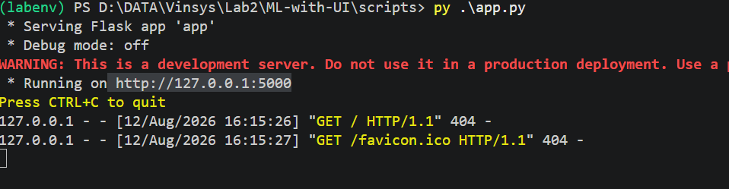

Step 4 - Call Endpoint

Callapi.py
import requests
url = "http://127.0.0.1:5000/predict"
payload = [{
"MonthlyDataUsage":12,
"AverageCallCount":130,
"MonthlyBill":900,
"UsageBillingRatio":0.013
}]
response = requests.post(url, json=payload)
print("Response:", response.json())

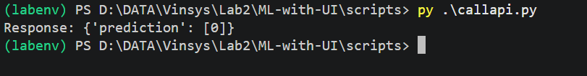

 Outcome
- train a small model locally
- Flask serves it as an endpoint (http://127.0.0.1:5000/predict)
- Python client sends JSON and receives predictions

